Collateral Web

TFS 92351 – Enhance scenarios for object ownership;

TFS 92357 – Multiple Collateral Scenarios

Feature Overview

Modify the process by which scenarios are created and modified to include various scopes. This is to help draw awareness to existing scenarios that already include a certain scope and hopefully minimize, if not completely eliminate, the need for data cleanups.

# Document Change History

|  |  |  |  |  |
| --- | --- | --- | --- | --- |
| Version | Date Changed | Description | Approved By | Date Approved |
| 1 | 08/26/16 | Document started | Rebeca McFarland | 08/26/16 |
| 2 | 09/08/16 | Updated mock-ups and other edits | Bevin Morrissey | 09/08/16 |
| 3 | 09/22/16 | Design regroup | Bevin Morrissey | 09/23/16 |
| 4 | 10/21/16 |  |  |  |

FPI Credit Products

September 23, 2016

Table of Contents

Collateral Web 1

Document Change History 1

Statement of the Problem 2

FPI RECOMMENDATION 3

View Current Production 4

Create New Scenario 5

Continue with Existing Scenario 7

Edit Scenario Scopes 9

Association Parameter 10

Collateral Analysis Screen 10

Submitting Scenarios to EmPOWER 11

TFS 92351 – Enhance scenarios for object ownership; TFS 92357 – Multiple Collateral Scenarios

## Statement of the Problem

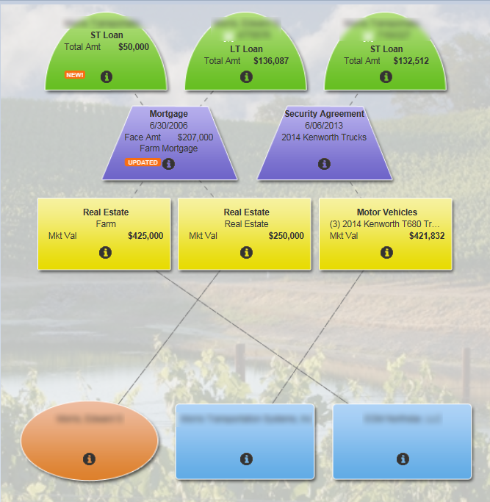

**Employee #1** is working on the **short term loan** on the right side of the picture in an existing scenario.

**Employee #2** is working on the **short and long term loans** on the left side of the picture.

If one of these two employees updates collateral belonging to a loan in the same scope, the two scenarios become entangled and FPI has to manually clean up data in the database with a script.

We would like to make it more obvious which collateral objects belong to which scope, and make it more difficult to lock up scenarios by creating multiple scenarios that include the same scope.

## FPI RECOMMENDATION

When either employee is in the same scope, **each employee will receive two alerts** to inform them a scope will be affected.

1. Scope Exists in Another Scenario
2. Scope(s) Will Be Cancelled

Scope Exists in Another Scenario

If a scenario already exists and **Employee #2** edits a scope that is already included in the existing scenario, the following alert appears:

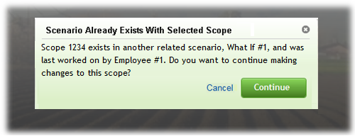

Employee #2 can choose to:

* **“Cancel”** to return to Current Production
* **“Continue”** to Create New Scenario

The alert will notify Employee #2 **who is working** on that scope and **which scope(s)** will be affected.

**Employee #1** **will also receive an alert** to notify them that changes have been made to Scope 1234 by Employee #2. If Employe #1 is in CW, this alert will pop up as soon as Employee #2 makes changes.

The **orange alert** will only alert them that unsubmitted changes have been made.

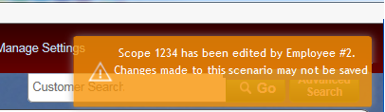

These alerts will only appear the first time that the scope is edited. After a new scenario is created, Employee #2 can edit anything in that scope and neither employee will receive any additional alerts.

Scope(s) Will Be Cancelled

If **Employee #2** attempts to submit a scenario that includes a scope Employee #1 has made changes to, Employee #2 will receive the alert:

**“During the submit process, the following scope(s) will be cancelled: Scope 1234. (Employee #1)”**

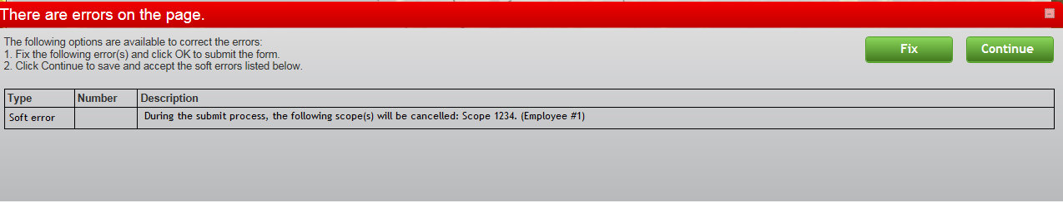

Employee #2 can choose to:

* **“Fix”** and **not** **submit** the scenario
* **“Continue”** **to** **submit** the scenario

If the scenario is **submitted**, Employee #1 receives the alert:

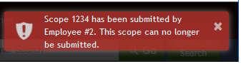

This alert will prevent Employee #1 from being unaware that the work they are doing can not be submitted.

Currently, Employee #1 would have their entire scenario deleted. They would have to start over from Current Production.

Undo/Redo Changes

**NO idea of this is even possible but I’m just throwing this against the wall.**

If Employee #2 chooses not to submit the scenario and selects **“Fix”**, they have the ability to “**Undo Changes”** for the entire scope that was affected.

This change would give Employee #2 the opportunity ensure Employee #1 does not lose any work.

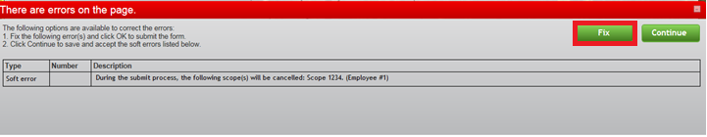

After selecting “Fix”, Employee #2 has the option to Undo the changes

